**Skater Name**

This is a text box. Click (or double click) to edit the text in here. You can change the font type and/or size.

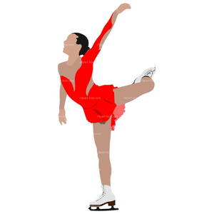

This is another text box. You can always click the box and delete if you do not want it.

PS Double clicking on the photo should give you an option to “Change Picture”.

For assistance, email sponsor@NSskating.org

This is also a text box. Click (double click) to edit the text in here. You can type a message in here. You can also click on the text box and copy (CRTL+C) to add another text box. These are set so that you can grab and drag them to where you want them on the page. And you can grab a side and drag it in to make the box smaller/narrower. We have set this paragraph to be justified so both the right and left sides are justified.

The words/images can go all the way to the edge. This is set to the size of the ad.